**Living-Off-The-Land Lab**

**Table of contents**

1. Lab Objective 3

2. Tools 3

3. Lab Execution 3

4. Lab Logs 6

5. Summary 6

**List of Figures**

Figure 3.1 Shows AV bypassed and all process listed 4

Figure 3.2 Shows all local users on system 4

Figure 3.3 Shows current user 5

Figure 3.4 Harvesting credentials 5

Figure 3.5 Shows cleaning up of exported files 5

**List of Tables**

Table 2.1 Shows Tools 3

Table 4.1 Shows Logs 6

# Lab Objective

* Demonstrate attacks using native Windows tools (PowerShell, WMI).
* Perform file-less execution to bypass antivirus.
* Harvest system credentials safely in a lab environment.

# 2. Tools

| ***Tool*** | ***Purpose*** |
| --- | --- |
| PowerShell | Execute fileless attacks in memory |
| WMI | Enumerate users and harvest credentials |
| Windows VM | Target system for simulation (IP: 192.168.1.38) |

##### Table 2.1 Shows Tools

# 3. Lab Execution

***Step 1:*** Fileless PowerShell Execution

# Encode a PowerShell command

***$command = 'Get-Process'***

***$bytes = [System.Text.Encoding]::Unicode.GetBytes($command)***

***$encoded = [Convert]::ToBase64String($bytes)***

# Execute encoded command (fileless)

***powershell.exe -NoProfile -ExecutionPolicy Bypass -EncodedCommand $encoded***

***Observation:*** Processes listed without creating any files on disk. AV bypassed in lab simulation.

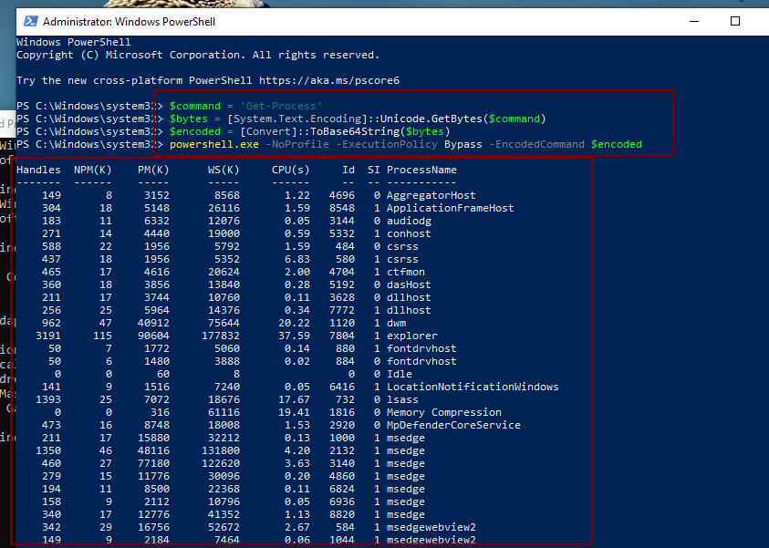

#### Figure 3.1 Shows AV bypassed and all process listed

***Step 2:*** Credential Harvesting via WMI

List Local Users

***Get-WmiObject Win32_UserAccount -Filter "LocalAccount='True'"***

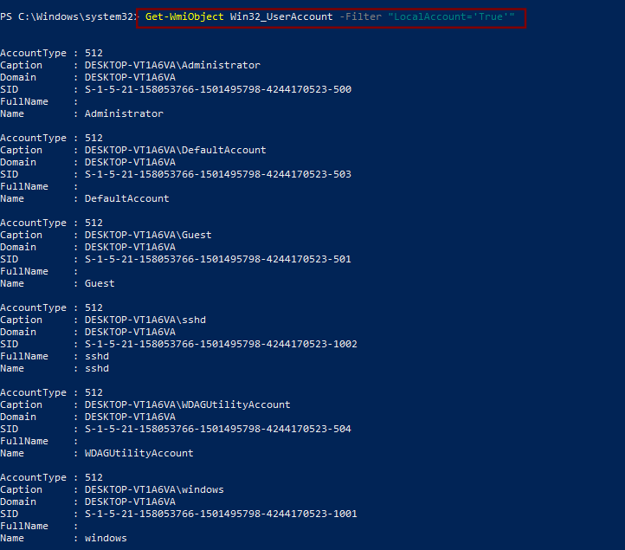

#### Figure 3.2 Shows all local users on system

***Step 3:*** Show Current Logged-In User

***Get-WmiObject -Class Win32_ComputerSystem | Select-Object UserName***

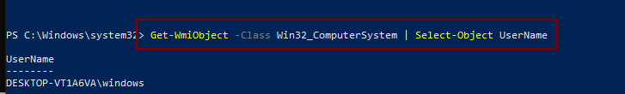

#### Figure 3.3 Shows current user

***Step 4:*** Simulated Credential Extraction

***Get-WmiObject Win32_UserAccount -Filter "LocalAccount='True'" |***

***Select-Object Name,SID | Export-Csv C:\Lab\UserList.csv***

***Observation:*** Local user accounts exported safely, simulating credential harvesting.

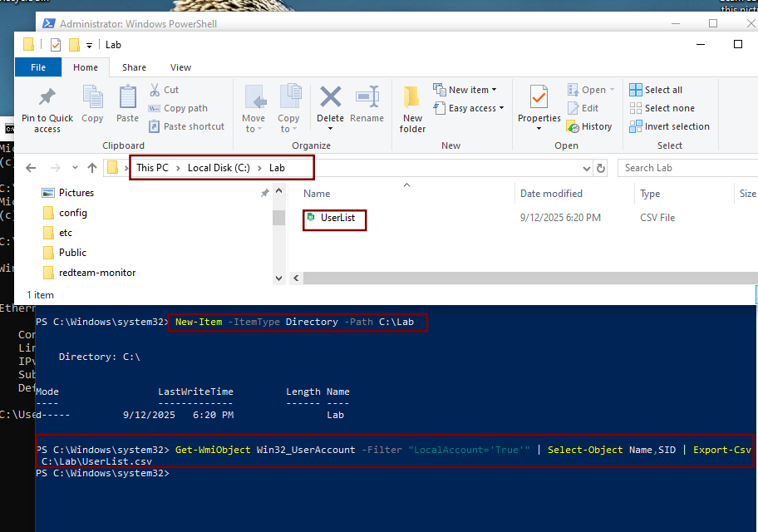

#### Figure 3.4 Harvesting credentials

***Step 5:*** Cleanup

***Remove-Item C:\Lab\UserList.csv***

cleanup

#### Figure 3.5 Shows cleaning up of exported files

# 4. Lab Logs

| ***Attack ID*** | ***Tool*** | ***Action*** | ***Notes*** |
| --- | --- | --- | --- |
| LID001 | PowerShell | Fileless execution | Bypassed AV |
| LID002 | WMI | Credential harvest | Extracted user info (simulated) |

##### Table 4.1 Shows Logs

# 5. Summary

In the Living-Off-the-Land lab, native Windows tools were leveraged for stealthy attacks. PowerShell enabled file less execution, bypassing antivirus detection, while WMI enumerated and harvested credentials from the system. This demonstrates how attackers can abuse legitimate system tools to perform malicious actions without leaving traces.